# Schematic and Parts List

Below left: This is showing ½ of the full schematic.

Below right: This is the full PCB with two identical circuits as shown in the schematic. (With a common DCC input)

|  |  |  |  |  |  |
| --- | --- | --- | --- | --- | --- |
|  | | |  | | |
| Parts list for ½ of the PCB | | | | | |
| Qty | | Designation | Description | | Part No | Source |
| 2 | | R1, R2 | 6.8K ¼ watt TH Resistor | |  | Widely available |
| 2 | | D1, D2 | 1N914, (or 1N4148 or equivalent) | |  | Widely available |
| 2 | | LED1a, LED1b | 5mm LED (two different colours) | |  | Widely available |
| 2 | | U1, U2 | TLP241(A or B) or TLP3554 Solid State photo-relay (MOSFET output) | | Mouser:  757-TLP241AD4F  or  757-TLP241BD4F | Mouser (Check on line)  (I do not recommend AliExpress for TLP3554) |
|  | |  | 0.254mm (0.1 in) in line header pins  Optional depending on your build. | |  | Widely available |
| 1 | | J1 | DCC Input.  Can use PCB mount screw terminals or solder wires direct to PCB. Multiple options of pin spacing are provided. | |  | Widely available |
| 1 | | Signal LED output connector | Small 0.254mm (0.1 in) pitch PCB mount screw terminals (recommended). You Could wire up direct also. | |  | Widely available.  (Prices vary widely) |

**Step by Step (For the left half):**

|  |  |  |  |
| --- | --- | --- | --- |
| Step | Instructions | Comments |  |
| The steps below follow a general good practice by starting with the components closest to PCB first. | | |  |
| 1 | D1, D2, R1, R2 | Note D1 and D2 are oriented opposite each other. The white band on the PCB indicates the cathode. On glass diodes the cathode is indicated with a black band. |  |
| **The First Decision** | Will you be installing the photo relays?  (They are optional) | If you are only switching LED signals the photo relays are not needed. The relays can be used for switching other independent circuits (higher power). | |
| **NO** | Install small wire jumpers in places marked BP1 and BP2. | BP1 and BP2 are bypasses (you’ve got to have bypasses!).  I use short lengths of resistor or diode leads bent over into a staple shape. (Available from step 1 above) | Electrically they jump over where the photo-relay LED would be without ruining the PCB should you wish to retrofit the relays later. |
|  | Proceed to Step 3 |  |  |
| **YES** | Install U1, U2  See comments about the optional 2 pin headers. (4 locations) | Note all of the photo-relays are oriented the same. On the relay itself pin 1 is usually marked with a ‘dot’ (I also show this on the PCB to be as clear as possible).  Additional 2 pin headers (S1 and S2) can be installed as connection points for the **photo-relay MOSFET** **outputs.**  **Note:** This PCB does not use or need the MOSFET outputs – they are for controlling **your** external circuitry! |  |
|  | LED1a, LED1b | I recommend picking 2 different LED colours for disambiguation. Note the LED’s are oriented opposite each other. The long lead is the Anode (+ve) while the Cathode (-ve) has a flat molded into the plastic. On the PCB the cathode has a square mounting pad and I have also put a white line where the flat side is.  This is readily visible in the photo above. |  |
| 3 | J2 = 3 pin header | Connection point for a SPDT switch  (The auxiliary contact from a point motor for example.)  It is your choice if you want to wire directly to the printed circuit board or mount a 3 terminal header as I have done. |  |
| 4 | PCB mount screw terminals for the output LED’s | Small screw terminals are recommended. (Makes it easy to reverse the indication)  You could wire direct to the PCB with soldered connections. |  |
| 5 | PCB mount screw terminals for the DCC input (used to drive LED’s only) | This one input provides the power to both halves of the PCB. (The second half may not even be populated.) There are multiple options for this connection to suit your preference.  The only thing the DCC power does is drive the LED’s via the 6.8K current limiting resistor. (Power demand is very low). |  |

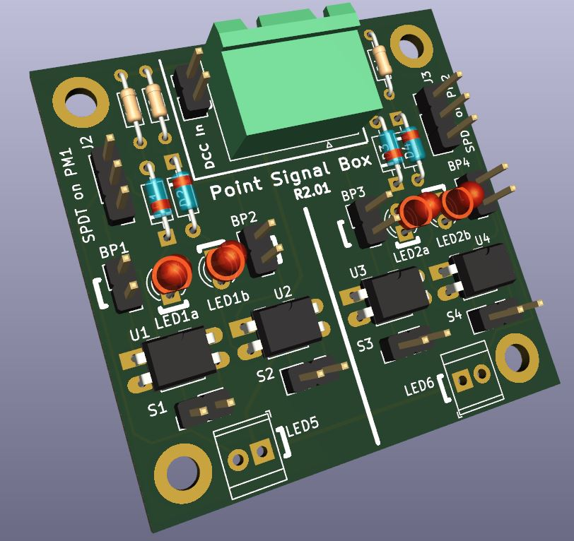

# Final Comments on the Build Process

The second identical circuit on the right half is built up in the same way and can be used for completely separate SPDT input driving a completely separate LED signal. If you are only controlling one signal from one auxiliary switch you do not need to build both halves of course.

# How The Circuit Works

Referring to the figure below the SPDT switch simply selects either the left path or the right path.

The two paths differ in that the diodes are arranged in opposite directions ensuring that current only flows in one direction for a given path.

The net effect is that the SPDT switch selects one branch and then current only flows in one direction and therefore only one of the back-to-back LED’s will light up.

The key thing to the operation is that the supply voltage is DCC which is actually an AC waveform where the voltages on the wire flip back and forth (at several kHz frequency).

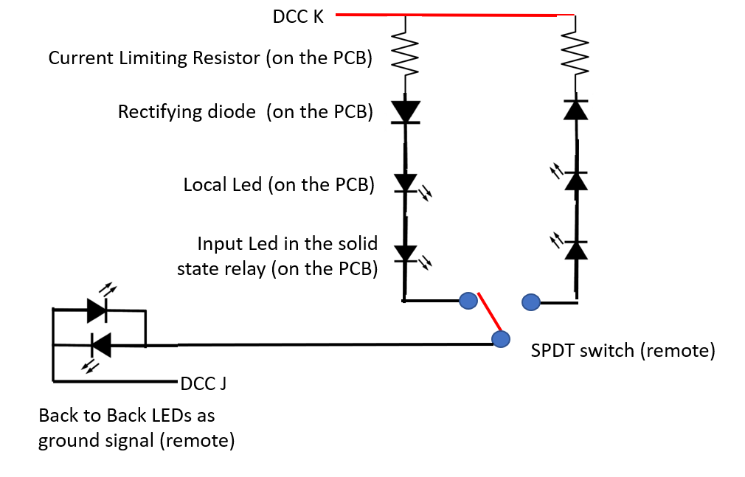

Below Installed on my (still under construction) layout. The signal is indicating the status of point #509 which is hidden from view on the far side of the over bridge.

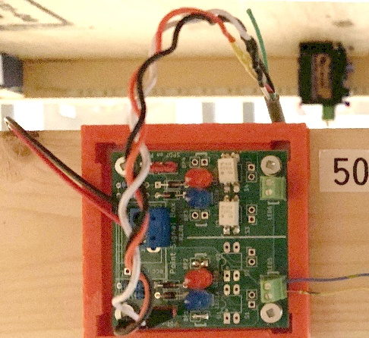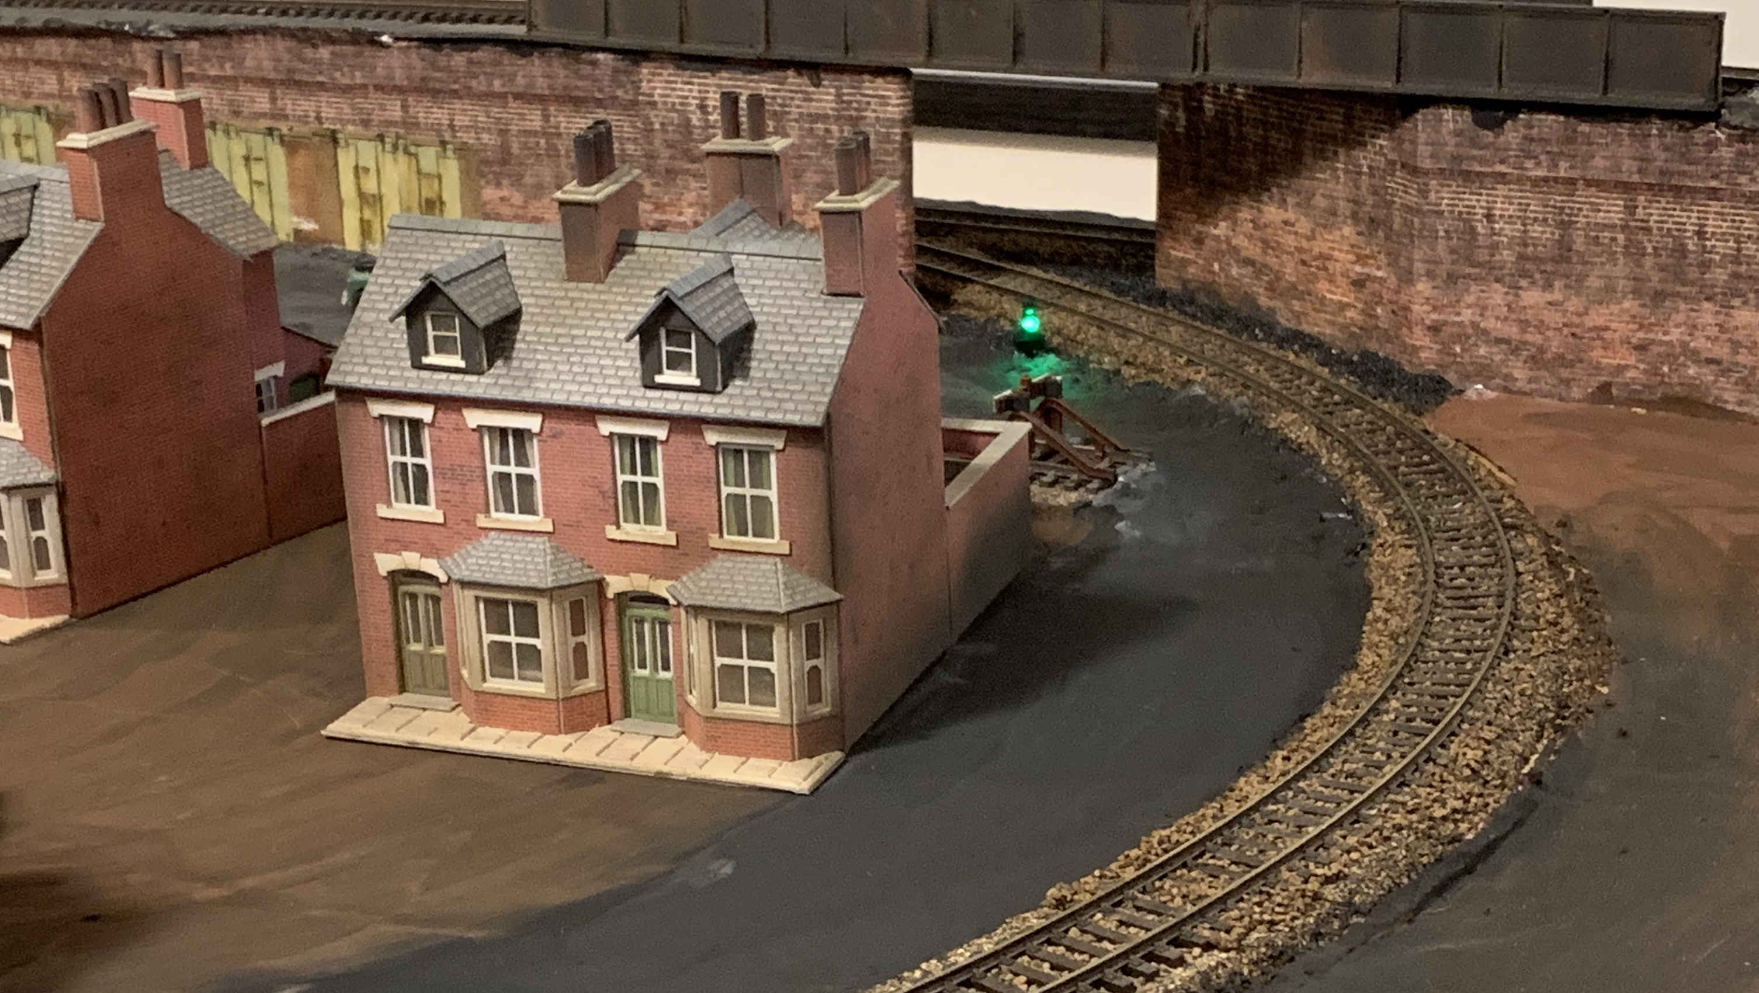

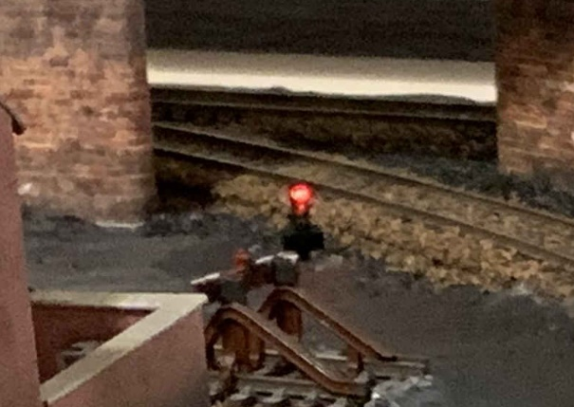To the left is the module installed under the layout with point motor #509 in the background. This point is not readily visible from the normal operating location.

With the LED’s installed above now a quick glance at the layout indicates the point position.

# Change Log

|  |  |  |  |  |
| --- | --- | --- | --- | --- |
| Rev | What | Comment | Date | PCB’s  Ordered/Delivered/Built |
|  | Initial Design | This was the flawed H bridge design | Sept 2022 | Yes / Yes / No |
| 0 | Revamp Design | 4 circuits per PCB. (8 legs). No Photo Relays | Sept 2022 | Yes / Yes / Yes |
| 1 | Add Photo Relays | 4 circuits per PCB. Added photo relays. (Was never ordered) | Sept 2022 | No /No / No |
| 2 | Reduced PCB size | 2 circuits per PCB. With photo relays. | Oct 2022 | Yes / Yes / Yes |
| 2.01 | Minor  Improvements | **PCB:** SS Relays : pads made larger for use with SMD  **Silkscreen:** fixed missing part references,   * added LED polarity markers * added text | Oct 2022 | Yes / Yes / Yes |